EPIF end of year summary 2015

# Overview

This report contains a brief summary of research activity under the EPIF project from April 7th – December 31st 2015. The purpose is to document the various analyses conducted with reference to the original and updated project proposal. Plans for research and analytical support activities for 2016 are also outlined. The report is broken into work-package activity.

### 

Table of Contents

Overview 1

Work package developments 2015 2

WP1a – Meta-analysis 2

WP1b – Technical Measure Experimental design and data analysis 3

Technical Measure Experimental design 3

Data analysis 3

Work plan 2016 4

Gear technology 4

Price Analysis 4

Univariate (single species) price analysis 5

Multivariate (multiple species) price analysis 5

Albacore tuna analyses 6

# Work package developments 2015

## WP1a – Meta-analysis

WP1a called for a framework for meta-analysis (mainly for whitefish). Gaps analysis here refers to identification of gaps in the experimental design rather than gaps in the statistical methods (WP1b). Initial discussion of whitefish trials previously conducted using grids of parameter estimates from trial design (cod-end mesh and panels tested) highlighted that there was a gap in the design for the 70mm cod-end mesh (Figure 1).

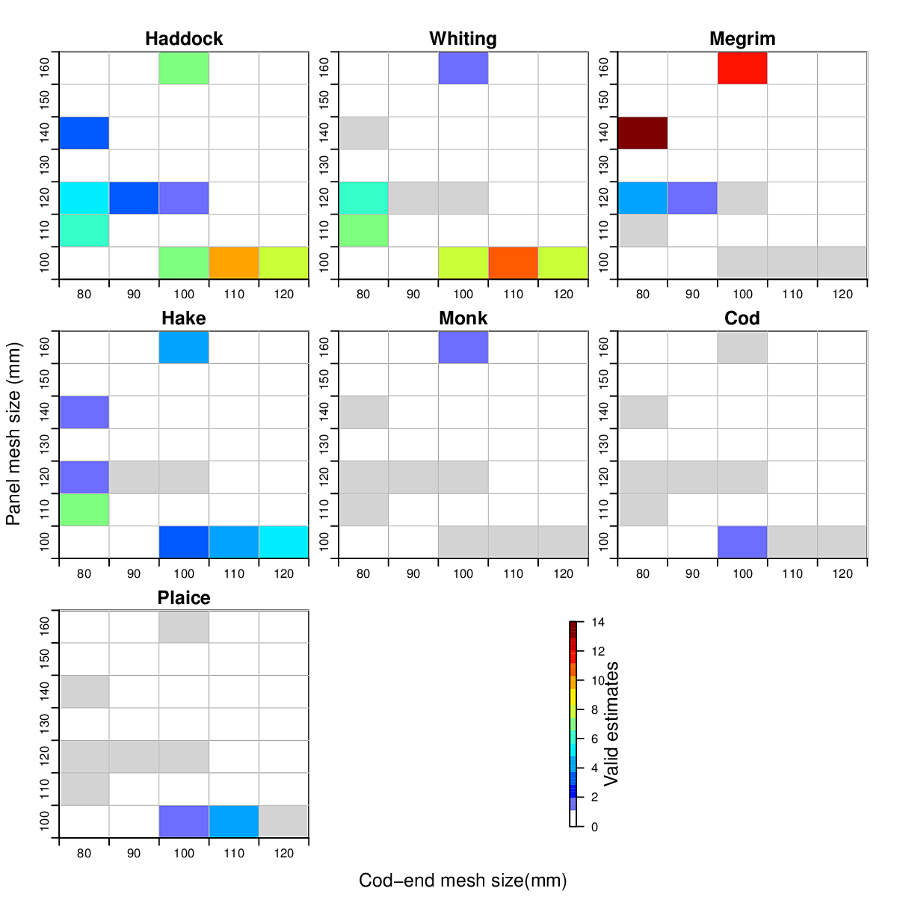

Figure 1. Gap analysis used for discussion on whitefish trials. Each grid cell represents a combination of a cod-end mesh size and panel mesh size trialled in selectivity experiments. The colour indicates the number of L50 parameters estimated for that combination. Grey indicates a trial conducted but insufficient data to estimate the parameters.

## WP1b – Technical Measure Experimental design and data analysis

### Technical Measure Experimental design

A simulation model for abundance-at-length and fishing of *Nephrops* in the Western Irish Sea was developed for the specific purpose of assisting BIM Gear Technologists in planning and executing gear trial experiments. Simulation code comprised three main elements

* 1. Abundance simulation
     + Length distributions on the grounds, based on previous trials
     + Burrow density using underwater camera survey
  2. Gear contacts
     + Based on the swept area of a tow
     + Assumed probability of emergence
  3. Fishing Gear Simulation
     + Simplified estimation of how the gear may affect catch composition
     + Estimate the number of *Nephrops* contacting the net per hour
     + Simulating the Relative fishing intensity of each of the gears with realistic difficulties such as door and net effects included

A central question from the gear technologists was what influence does net position have on the retention was address using this simulation framework. Results (Appendix IV) highlighted the importance of net rotation to mitigate for position effects. This resulted in a development in trial design brought about by close collaboration.

It is envisaged that further development of the power analysis simulation framework will assist in the design and implementation of additional trials during the course of the EPIF project.

### Data analysis

Work Package 1b focuses on the development of modelling frameworks for the analysis of gear trials which have been carried out by an Bord Iascaigh Mhara (BIM).

Gear trials conducted by BIM at this time were focused on the quad-rig trawl, that uses 4 nets towed by one boat, which is being utilised in the *Nephrops* fisheries, one of the most commercially viable fisheries in Ireland. Usage of this new gear along with the implementation of the landing obligation for this fishery necessitated evaluation of the catch of this gear so that improvements in management strategy could be made.

Gear technologists at BIM indicated the lack of literature on the efficiency and catch composition of this gear. Investigating the literature allowed for identification of gaps in the statistical methodology for analysing trawls or gears with more than 2 possible alternatives. We addressed this gap by extending the method of Holst and Revill (2009) for twin-rig trawls to two or more cod-end comparisons.

Initial model developments helped to identify necessary explanatory variables and model type (GLMM as opposed to GAMM). Also from the initial models variability which had not been taken into account was identified.

By working closely with gear technologists at BIM and completion of some preliminary analysis of trials (Appendix I, II, III) a number of recently concluded trials some important factors were identified for inclusion into our analysis such as; the inclusion of net rotation to account for net position effects and the importance of bulk weights in the cod-end per haul. Catch comparison analysis of the quad rig data provided to us gave a window into the importance of some variables and how much variability they accounted for when fitting models. This work has provided a statistical framework for analysing gear with 2 or more alternatives and has also helped in the identification of variables of importance for best fitting the model for these types of gears.

The focus was on the quad rig trial and a method for evaluating data which has more than 2 responses in the dependent variable.

* Justification for analysis (Landing obligation, new gear technology, management procedures)
* Expanding the dependant variable from binary regression to Multinomial regression
* Identification of necessary statistical package and programmes
* Development of preliminary multinomial models and the reason for it
* Focus was on explanatory variables which describe the dispersion in the data
  + Accounting for Haul variability was not enough
  + Weight in cod-end required (choice specific)
  + Addition of net configuration

This work culminated in the submission of the paper to the *ICES Journal of Marine Science*:

Browne, D., Minto, C., Cosgrove, R., Burke, B., McDonald, D., Officer, R. and Keatinge, M (in review). A general catch comparison method for multi-gear trials: application to a quad-rig trawling fishery for Nephrops.

# Work plan 2016

To accommodate dynamic requirements from BIM, the project plan for 2016 departs somewhat from the original project proposal. The plan for 2016 is presented below with specific details of analysis to be conducted.

## Gear technology

GMIT will continue to work on the design and analysis of gear trials with BIM Gear Technologists as required during 2016. Specifically, we will focus on (Daragh and Ronan to update here, briefly).

## Price Analysis

An imperative to understanding the implications of gear changes on the economic performance of fleet segments is to understand price dynamics. To date, price analysis have been relatively understudied. We will focus on developing a framework for price analysis at multiple levels.

Prices of fish may vary based on a multitude of drivers, including: supply (local and international), season, size/grade, condition, species, product differentiation, processing, etc. The goal of the EPIF price analysis (WP 4) is to investigate the influence of these factors on the price obtained at first point of sale by select segments in the Irish fleet, as identified by BIM. Methods will be trialled and discussed in close collaboration with BIM staff.

### Univariate (single species) price analysis

Here we focus on explaining variability in observed prices per species. Methods which can be explored for analysing univariate data would include regression approaches such as price elasticity models and time series methods such as autoregressive models (AR), moving average models (MA) or some combination of these (such as ARMA, or ARIMA models) which can be used for analysis of fish market dynamics and trends, taking the temporal aspect into account when fitting.

Regression Model:

* For example regressing price on quantity, quality, location, etc. This model can be used to derive varying price elasticities.

Autoregressive Model:

* Used to describe a random process, the model assumes that the output variable depends, linearly, on the previous values of the output variable and a stochastic error term.

Moving Average Model:

* Also used to describe a random process, the model assumes that the output variable depends, linearly, on current and previous values of the stochastic error term.

Autoregressive Moving Average Models (ARMA):

* Comprised of both autoregressive and moving average components.

### Multivariate (multiple species) price analysis

These analyses will focus on inter-relationships of prices among species and possibly locations (e.g., ports). Methods to be investigated include:

* Multivariate versions of the time series analysis highlighted above.
* Seemingly Unrelated Regression:

This model will be used in identifying relationship between different fish prices, identification of substitutes or inferior goods within fish markets for given fish.

It could also be used to analysis the price at port level, is there a coastal bias (additional transportation costs?) or port size bias (larger ports give lower prices?) when landing catches.

The Seemingly Unrelated Regression (SUR) model

* Runs a number of individual equations, each having a dependent variable and either the same or different predictor variables
* These equations are then generalized into a linear regression model
* The covariance structure of the residuals of these equations are then able to be taken into account providing efficient estimates which is then analysed to determine if a relationship between the equations exist.
* A number of methods can be used to evaluate the covariance structure such as OLS, GLS, FGLS, 2 Stage Least Squares, and 3 Stage Least Squares.
* Determination of the exact estimators (such as using FGLS, GLS or OLS) for the best estimates will require investigation of the data in question.

## Albacore tuna analyses

This work will be a collaboration between experts at BIM and analysts at GMIT to assist in the production of indices for ICCAT assessment of North Atlantic albacore tuna. Methods developed in previous collaborations will be extended temporally and new research on fleet dynamics contributing to the index will be explored by a PhD student at GMIT.